Face Treatments | Beautiful Eyes | Smooth Skin
BbK facials will deliver seriously noticeable results.  Clinical Peels  Peels are one of the most effective means of stimulating new, healthier skin growth. By removing cellular build-up and stimulating skin regeneration. Our peels offer improvement of wrinkles and fine lines, sun damage, pigmentation, pore size, acne and oil production. BbK skin peels are especially beneficial in the treatment of hyper pigmentation, general redness, acne, sun damage and ageing.  From 135 - 185  Bio-HydrodermTM  Bio-Hydroderm™ simultaneously cools and infuses your skin with advanced AQUA-FUSE™ solutions matched to your skin's needs, resolving your skin issues: dryness, ageing, fine lines, acne, hyper-pigmentation and excess oil from your very first treatment. More gentle than conventional micro-dermabrasion, hydrodermabrasion is non-irritating with clearly visible results.  45 mins 135  The Face Treatment  The ultimate in customisation to protect and restore the natural balance of your skin and send you into a wonderful state of relaxation. Kirsty will analyse your skin and select the right products and techniques to address your particular needs including: fine lines, skin elasticity, hydration, treating acne and soothing sensitive skin.  60 mins 115  45 mins 95 | Kirsty's reputation as an eyebrow expert precedes her. She will recommend an eyebrow shape that suits your facial structure then use premium wax, tweezing and trimming to achieve excellent results for you.  Eyebrow Shaping  Includes your initial consultation to assess and design the best brow shape for you.  32  + Brow Tinting 45  Eyebrow Tidy  Maintain or continue working towards your ideal brow shape.  25  + Brow Tinting 44  + Brow & Lash Tinting 60  Eyelash Lift  Give your lashes a beautiful 'just curled' look that will last for 6-8 weeks.  80  + Tinting 95.00  Eyebrow Tinting  Kirsty will mix the perfect custom colour for your brows to suit your hair and complexion.  22  Eyelash Tinting  Enhance your lashes with a rich dark tint.  30  Eyebrow + Eyelash Tinting  Have your brows and lashes looking their best.  48 | We use only the highest quality waxes that have been specifically selected to meet the individual needs of your skin to minimise irritation and ensure effective hair removal.  Bikini Wax  Many years of experience combined with the best products guarantee you smooth skin and minimised discomfort.  Standard 28  Extra 48  Full 58  Leg Wax  Super smooth legs either just to the knee or the full leg.  Half Leg 35  Full Leg 49  Underarm Wax  You won't believe how smooth and beautiful your underarms can be.  20  Upper Lip Wax  Far better than bleaching, let us take care of any hair that shouldn't be there.  17  Upper Lip Wax + Eyebrow Tidy  A 'once over' for your face that will leave you feeling tip top.  38  + Chin 52  + Eyebrow Tinting 69  Please contact us for more waxing areas

Body & Nail Treatments | 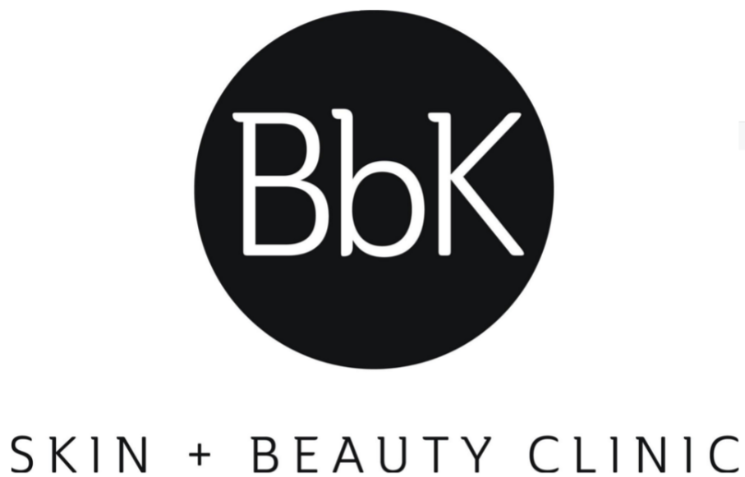  75 Prospect Road Prospect SA 5082  08 7225 4747  kirstya@internode.on.net  www.bbkskinandbeauty.com
Spray Tan
Kirsty will mix the colour specifically for you to ensure you look like you've just come back from a tropical holiday - minus the UV damage.

Refresher Manicure
Let us file your nails back into shape and apply your preferred shade of polish.
40
+ Shellac 48

Deluxe Manicure
Treat your hands to a massage, cuticle treatment, shaping and polish.
60
+ Shellac 68

Refresher Pedicure
Keep your toes looking tidy with shaping and polish.
48

Deluxe Pedicure
Treat your feet to the care they deserve with a relaxing massage, removal of hard skin, shaping and polish.
80
+ Paraffin 90

